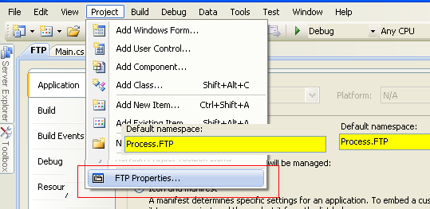

<section name="<NOMBRE SECCION>>" type="<Data Type>, <NAMESPACE>" />

App.Config

<?xml version="1.0" encoding="utf-8" ?>
<configuration>
<configSections>
<section name="Settings" type="Process.FTP.Settings, Process.FTP" />
<section name="emailSettings" type="Stream.Core.emailSettings, Stream.Core.Email"/>
</configSections>
<appSettings>
<add key="ClientName" value="Mac Office" />
<add key="eventSource" value="MACOFFICE_INBOUND_FTP" />
<add key="eventLog" value="MACOFFICE_INBOUND"/>
</appSettings>
<emailSettings
emailFrom="macofficeinboundftp@stream.com"
emailSubject="ERROR IN MAC OFFICE INBOUND FTP SERVICE"
smtpServer="mailedc01"
smtpPort="25"
smtpTransport="2"
smtpAuthentication="0"
smtpAuthUserName=""
smtpAuthPassword=""
smtpAuthDomain=""
smtpTimeout="60"
>
<emailToList>
<emailTo address="jim.roton@stream.com" />
<emailTo address="scott.gardner@stream.com" />
</emailToList>
</emailSettings>
<Settings debug="true">
<Clients>
<Client
id="mac.office.sftp"
ftpType="SFTP"
ftpHost="67.211.2.128"
ftpUserName="ftpuser56"
ftpPassword="x7yGg8"
/>
<Client
id="MacOffice.inbound.xftp"
ftpType="FTPS"
ftpHost="ftp://10.190.11.61/"
ftpUserName="MacOfficeibob"
ftpPassword="7p20Kab0"
/>
</Clients>
</Settings>
</configuration>

Main

using System.Configuration;

namespace Procesos.FTP

Option 1
private static string ClientName = System.Configuration.ConfigurationManager.AppSettings.Get("ClientName");

Option 2
private static Procesos.FTP.Settings Settings = (Procesos.FTP.Settings)ConfigurationManager.GetSection("Settings");

Settings.cs

using System;
using System.Configuration;

namespace Process.FTP
{
public class Settings : ConfigurationSection
{
[ConfigurationProperty("debug")]
public bool debug
{
get { return (bool)base["debug"]; }
}

[ConfigurationProperty("Clients", IsDefaultCollection = true)]
public Clients Clients
{
get { return (Clients)base["Clients"]; }
}
}

public sealed class Clients : ConfigurationElementCollection
{
protected override ConfigurationElement CreateNewElement()
{
return new Client();
}

protected override object GetElementKey(ConfigurationElement element)
{
return ((Client)element).id;
}

public override ConfigurationElementCollectionType CollectionType
{
get { return ConfigurationElementCollectionType.BasicMap; }
}

protected override string ElementName
{
get { return "Client"; }
}

public Client this[int index]
{
get { return (Client)BaseGet(index); }
}
}

public sealed class Client : ConfigurationElement
{
private string _ReportFileName;
public string ReportFileName
{
get
{
if (String.IsNullOrEmpty(_ReportFileName))
_ReportFileName =
DateTime.Now.Year.ToString() +
DateTime.Now.Month.ToString().PadLeft(2, '0') +
DateTime.Now.Day.ToString().PadLeft(2, '0') +
DateTime.Now.Hour.ToString().PadLeft(2, '0') +
DateTime.Now.Minute.ToString().PadLeft(2, '0') +
DateTime.Now.Second.ToString().PadLeft(2, '0') + ".csv";

return _ReportFileName;
}
}

[ConfigurationProperty("id", IsKey = true, IsRequired = true)]
public string id
{
get { return (string)this["id"]; }
}
[ConfigurationProperty("ftpType")]
public string ftpType
{
get { return (string)this["ftpType"]; }
}
[ConfigurationProperty("ftpHost")]
public string ftpHost
{
get { return (string)this["ftpHost"]; }
}
[ConfigurationProperty("ftpUserName")]
public string ftpUserName
{
get { return (string)this["ftpUserName"]; }
}
[ConfigurationProperty("ftpPassword")]
public string ftpPassword
{
get { return (string)this["ftpPassword"]; }
}
}
}

